James Salvatore Andur Circuit Function

As of 12/20/13

The Andur Harvester Circuit is intended to measure temperature. To do so, the output of an iPhone or iPad is sent to a thermocouple. The thermocouple amplifier then sends a voltage to a Voltage to Frequency Integrated Circuit. The outgoing frequency is sent back to the iPhone, which is read as the temperature by iOS code. The circuit’s process is shown in Figure 1.

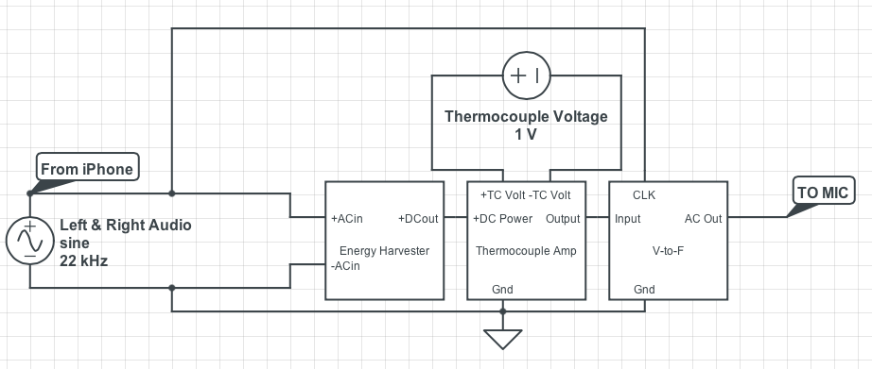

Figure 1. Andur Circuit Flowchart

Of course, the output of an iPhone is usually reached by a headphone jack, known as the TRRS jack, as pictured in Figure 2.

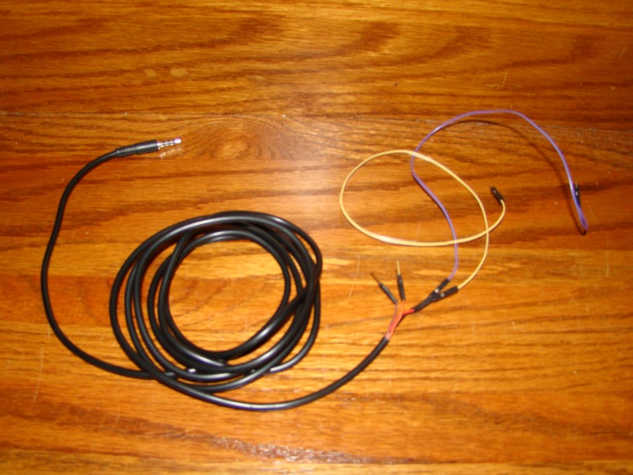

Figure 2. TRRS Jack

The jack being used contains wires corresponding to the four connectors on the jack (tip, ring, ring, and sleeve), which are shown in Table 1.

|  |  |  |
| --- | --- | --- |
| **Jack Component/Connector** | **Wire Color** | **Function** |
| Tip | Black (Purple) | Left Audio |
| Ring (Outer) | Orange | Right Audio |
| Ring (Inner) | Red (Yellow) | Ground |
| Sleeve | Brown | Microphone |

Table 1: TRRS Function

First, frequency from the iPhone, from the left audio connector, is passed through the Harvester portion on the breadboard. The circuit’s design was built using the “HiJack” design as a springboard. The 1:20 micro-transformer, Coilcraft LPR6235 model, increases the voltage from the iPhone. The Coilcraft transformer is pictured in Figure 5 and its pins are shown in Figure 6. An arrangement of capacitors stores the resulting energy and a diode prevents feedback voltage to the transformer. There is also an LED to show that energy is being fed to the circuit. A pair of resistors maintains a voltage of 5.1 V for linear regulation. This voltage is sent to the thermocouple amplifier.

The thermocouple amplifier in the Andur circuit is the AD8495 IC model, with the pin arrangement in Figure 9 in the Appendix. Given the IC’s arrangement, the voltage difference of the voltage reference (2) and the input (1 and 8) would be sent to the output (6), which would be connected to the input of the Voltage to Frequency IC. The V-F IC is model AD7740 and shown in Figure 10. With the voltage from the thermocouple, the frequency output (fout) is sent back to the iPhone via the microphone connector.

As of 12/20/13, the transformer has since been replaced with a transformer of the same make. Also, the LED has been removed and a MOSFET bridge was added, to rectify the voltage to DC. A thermocouple was also connected to the thermocouple amp IC. The circuit now looks as it does in Figure 11. As it stands, the positive frequency connects to the short blue wire on the top left corner. The negative frequency acts as the reference in the circuit and connects to the short yellow wire in the negative rail (-). A yellow wire in the circuitry and an orange wire in the negative rail is used to measure the Andur hardware’s output.

I thought it was unusual that the previous clinic did not include the MOSFET bridge in their final design. I saw that they tried and were not satisfied with HiJack’s design, but did not understand what the changed. It did not occur to me until later that the MOSFET bridge did not need to be there. However, after having a student in the clinic consultant look at it, he determined that the bridge did need to be there. I tried getting results by comparing voltages and frequencies passed through the circuit and reading them on the oscilloscope. I tried comparing the circuit’s values, both with and without a MOSFET bridge, with the graph in Figure 12. Since the version without a bridge did not resemble the graph, I was convinced that the MOSFET bridge needed to be integrated into the breadboard. So, whether or not the bridge is still needed is still unknown.

APPENDIX:

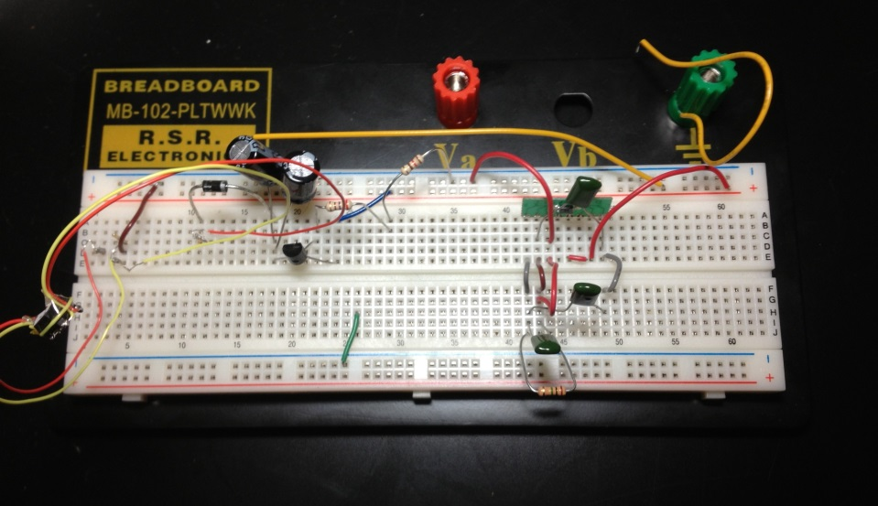

Figure 3. Harvester Circuit (Previous Clinic)

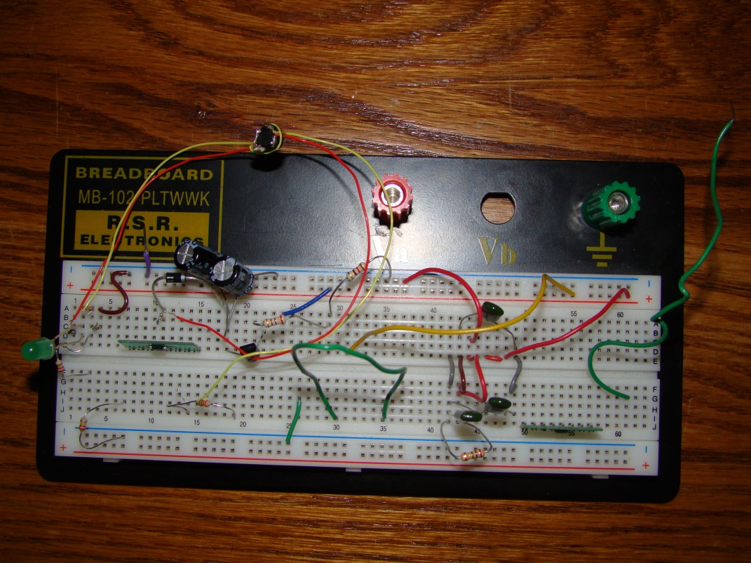

Figure 4. Harvester Circuit (Current Clinic)

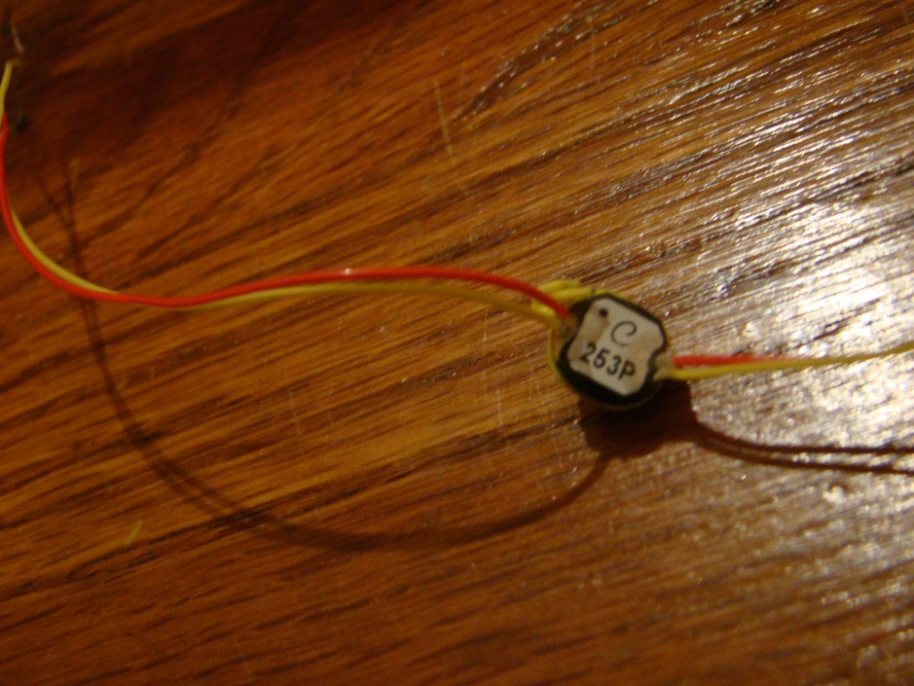

Figure 5. Coilcraft LPR6235 Transformer

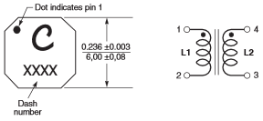

Figure 6. Coilcraft LPR6235 Pin Coordination

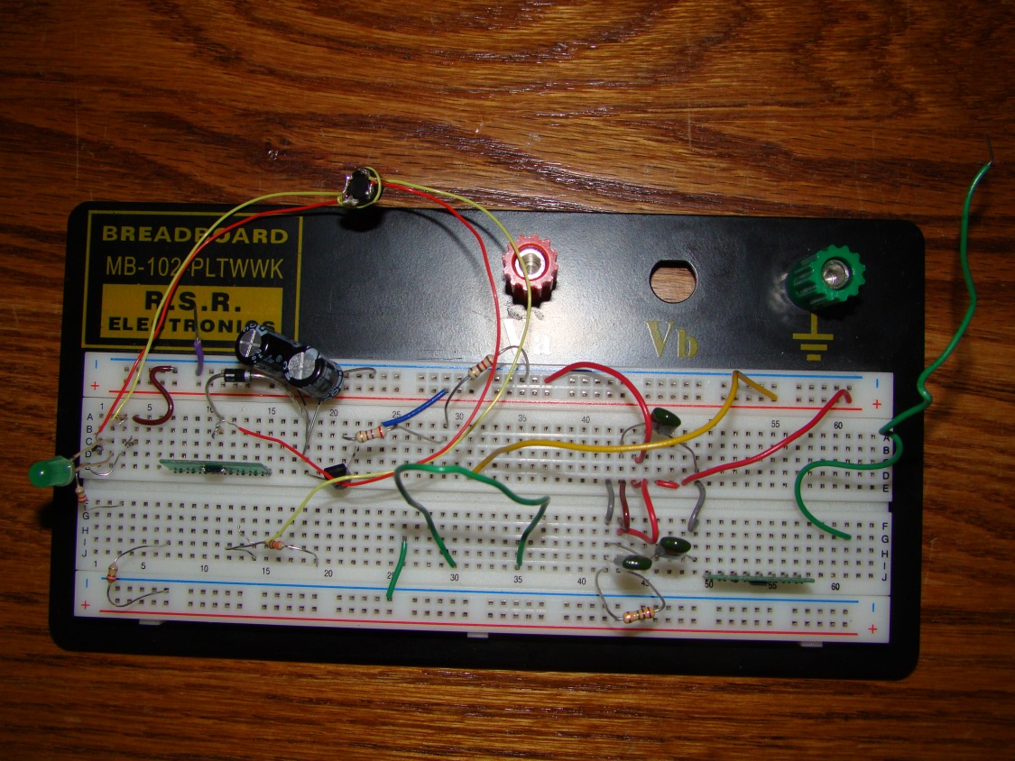

Figure 7. Harvester Circuit

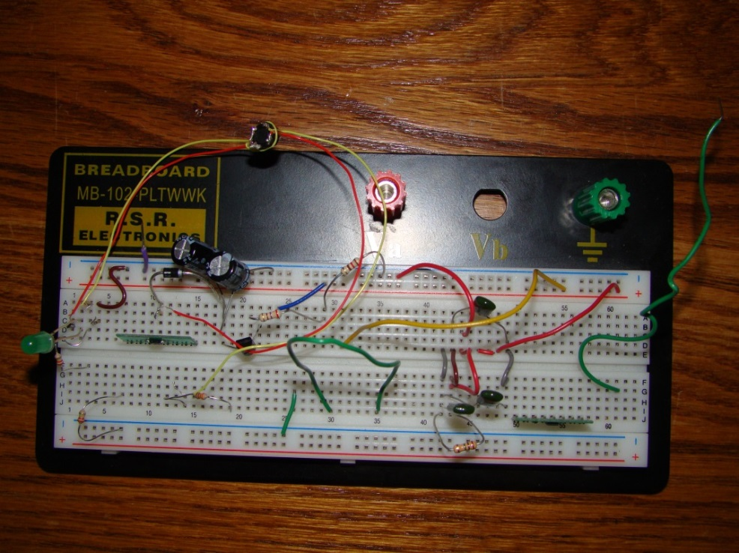

Figure 8. Unknown Portion on Breadboard



Figure 9. AD8495 Thermocouple Amplifier IC schematic



Figure 10. AD7740 Voltage to Frequency converter IC schematic

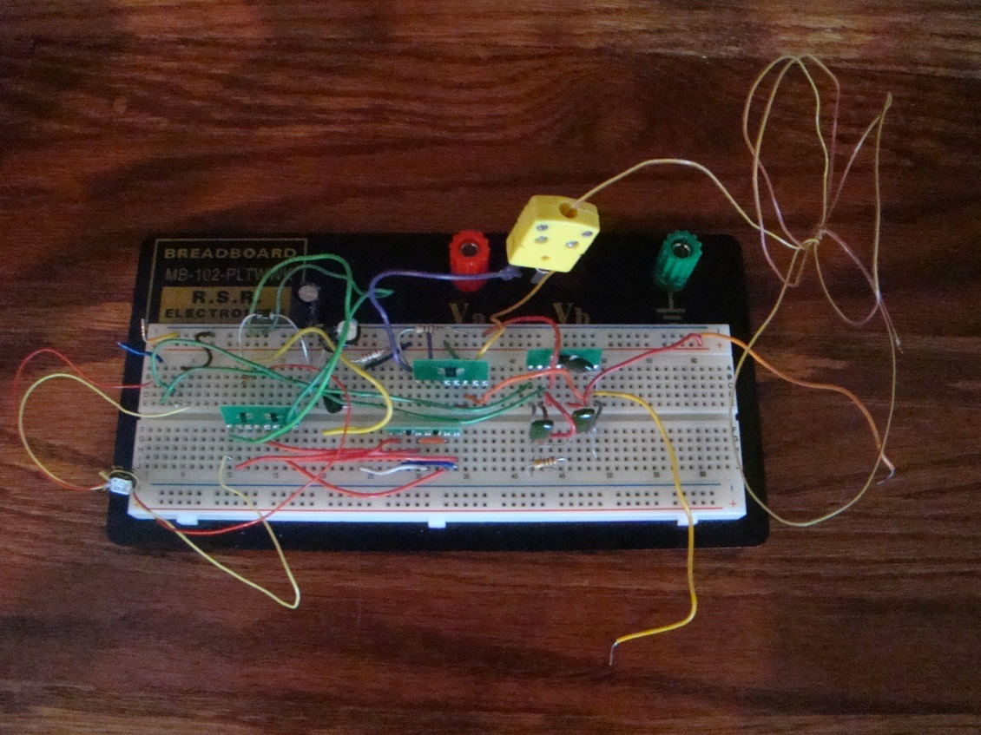

Figure 11. Circuit as of 12/20/13